Bellabeat Case Study
How Can a Wellness Company Play It Smart?
Google Data Analytics Capstone · Junior Data Analyst
Author: Luca Mulazzi · June 2026

Executive summary
Analysis of FitBit data (33 users, Apr 12 – May 12, 2016) to identify smart device usage trends and turn them into marketing recommendations for Bellabeat. Key results: the average user takes 8280 steps per day (below the recommended 10,000), stays sedentary about 15.8 hours and sleeps 6.99 hours. More movement is associated with more calories burned (r = 0.57); more sedentary time is associated with less sleep (r = -0.6). Sleep and weight are under-tracked (24 and 8 users out of 33). Three marketing recommendations are built on this evidence.

Methodology: the 6-phase process
The project follows the Google Data Analytics framework: Ask, Prepare, Process, Analyze, Share, Act. Each phase below is described with its objective, the work done and the result.

1. Ask — Define the problem

Objective
Understand the business task and stakeholders before touching the data.

What I did
- Defined the business task: identify trends in fitness smart device usage and translate them into marketing recommendations for a Bellabeat product.
- Set the three guiding questions: what trends exist, how they apply to Bellabeat customers, how they influence marketing strategy.
- Identified stakeholders: Urška Sršen (CCO, decision maker), Sando Mur (cofounder) and the Marketing Analytics team.

Result
A clear statement of the business task that guides all later phases.

2. Prepare — Collect and assess the data

Objective
Source the data and understand its organization, credibility and limitations.

What I did
- Used the public FitBit Fitness Tracker Data (Kaggle, CC0 license, via Mobius): 30+ users, minute-level data on activity, heart rate and sleep, from April 12 to May 12, 2016.
- Selected the relevant files: dailyActivity, sleepDay, hourlySteps and weightLogInfo.
- Assessed credibility with the ROCCC criterion and documented the limitations.

ROCCC assessment and limitations
- Reliable / Current: low — small sample (~30 users) and data from 2016.
- Comprehensive: missing demographics (sex and age), critical for a women's brand.
- Small samples: sleep tracked by only 24 users, weight by 8 (Fat column empty in 65 of 67 records).

Result
A complete description of the data sources and awareness of the limitations, to be carried into the final recommendations.

3. Process — Clean and transform

Objective
Ensure correct, consistent and analysis-ready data, documenting every step.

What I did (in Python / pandas)
- Loaded the CSVs into DataFrames and inspected dimensions, unique users, duplicates and missing values.
- Removed 3 duplicate rows from the sleep file.
- Converted dates from text to datetime with an explicit format, to avoid month/day ambiguity.
- Created derived columns: weekday, total active minutes, sedentary hours, hour of day, hours asleep, time awake in bed.
- Identified and isolated days when the device was not worn (1440 sedentary minutes = 24h), to avoid skewing the averages.

Tools
Python with pandas (manipulation), matplotlib and seaborn (charts), in a Jupyter notebook: a reproducible and fully documented choice, ideal for a portfolio.

Result
A clean dataset (activity_valid) and a traceable record of the cleaning.

4. Analyze — Find the patterns

Objective
Aggregate the data and identify trends, statistics and relationships useful to the business.

What I did
- Computed descriptive statistics: an average of 8280 steps/day, 2351 calories, 15.8 sedentary hours, 6.99 hours of sleep.
- Measured correlations: steps–calories r = 0.57 (positive); sedentary–sleep r = -0.6 (negative).
- Merged activity and sleep to compare them on the same day and user.
- Segmented users by device usage frequency (high/moderate/low): most wear it 21–31 days.
- Analyzed hourly patterns (peaks 12-2pm and 5-7pm) and weekly patterns (Saturday the most active, Sunday the least).

Key findings
- Low activity and high sedentary time: ample room to encourage movement.
- More steps = more calories: a concrete motivational feedback.
- More sedentary time = less sleep: a lever to connect activity and rest.
- Sleep and weight under-tracked: features to promote.
- Usage peaks at lunch and in the evening: ideal windows for notifications.
- Loyal users: engagement must be nurtured, not won from scratch.

Result
A set of quantitative findings that answer the business questions.

5. Share — Visualize and communicate

Objective
Turn the results into clear visualizations for stakeholders.

What I did
Created six charts with a palette consistent with the Bellabeat brand:
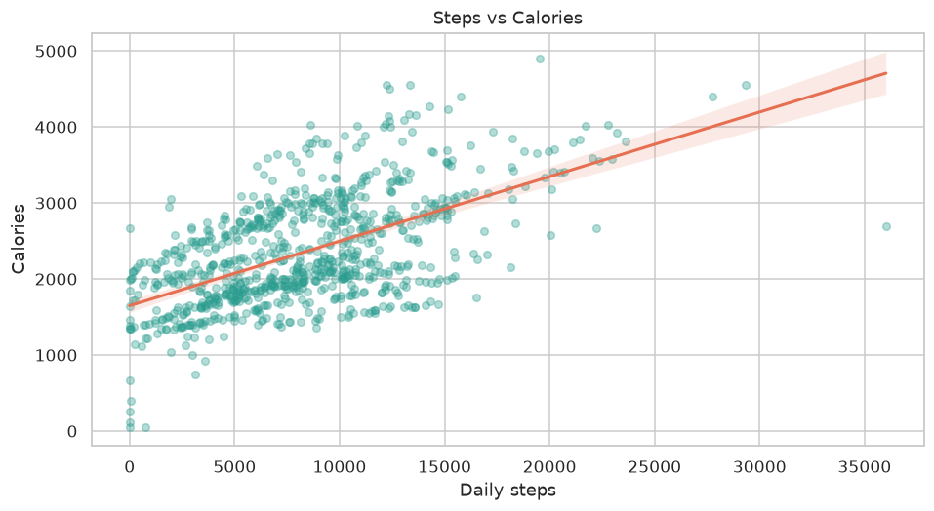
Positive relationship between steps and calories burned.
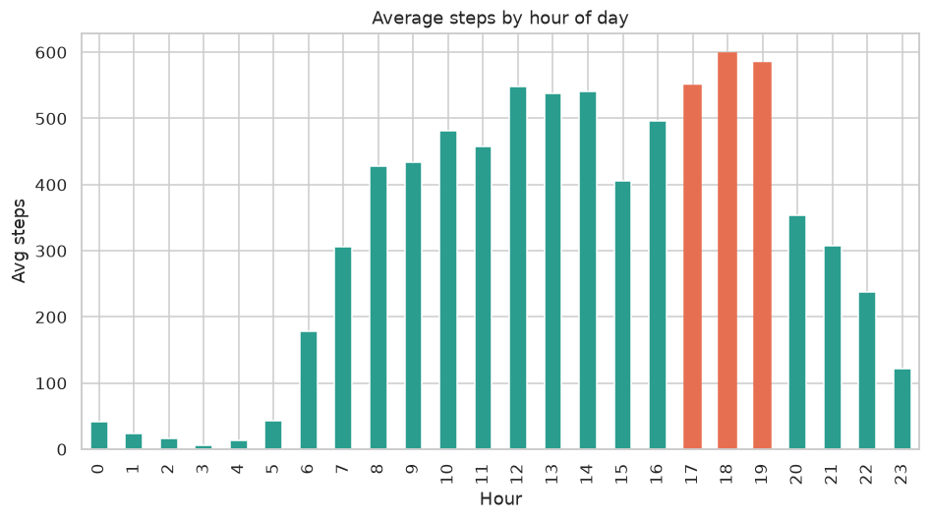
Average steps by hour of day: peaks at lunch and in the evening.
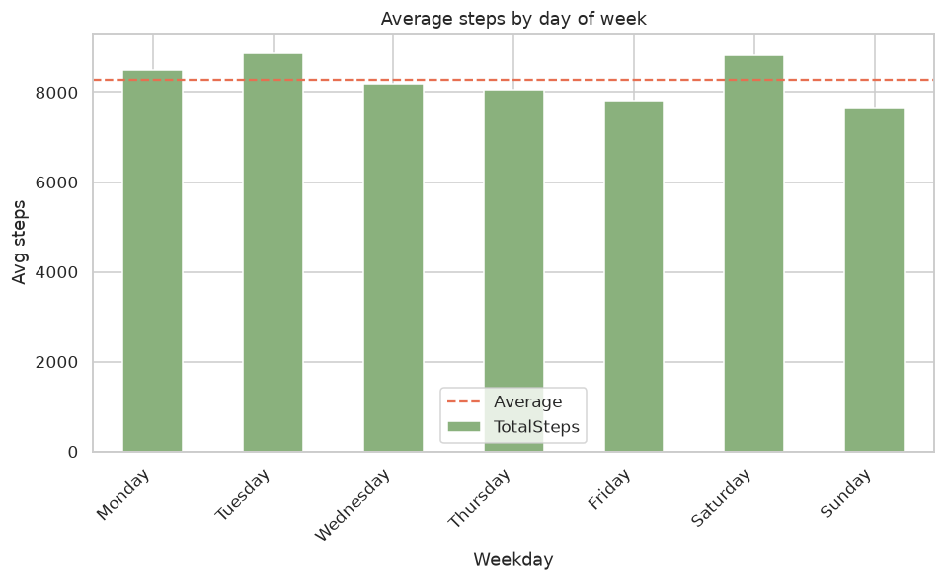
Average steps by day of the week.
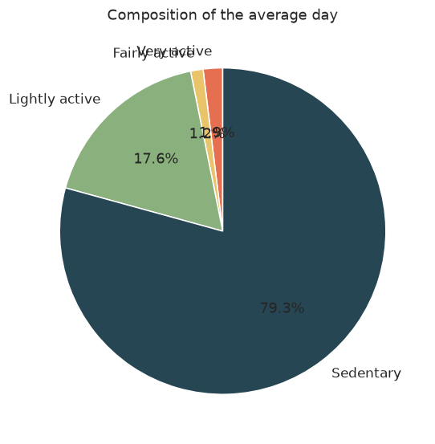
Composition of the average day: predominance of sedentary time.
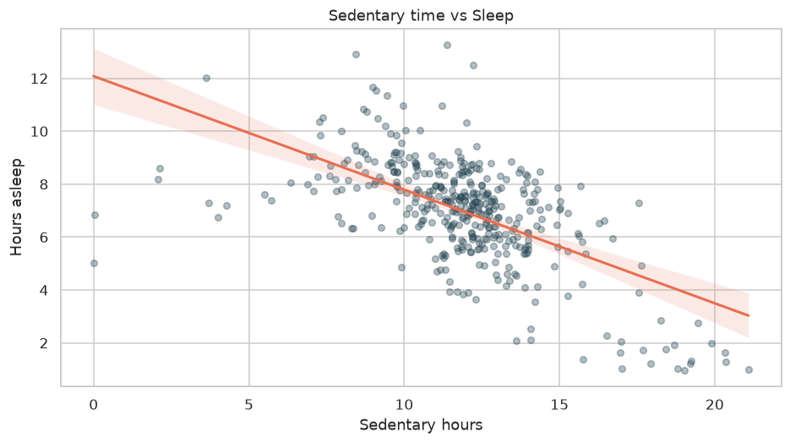
Negative relationship between sedentary hours and hours of sleep.
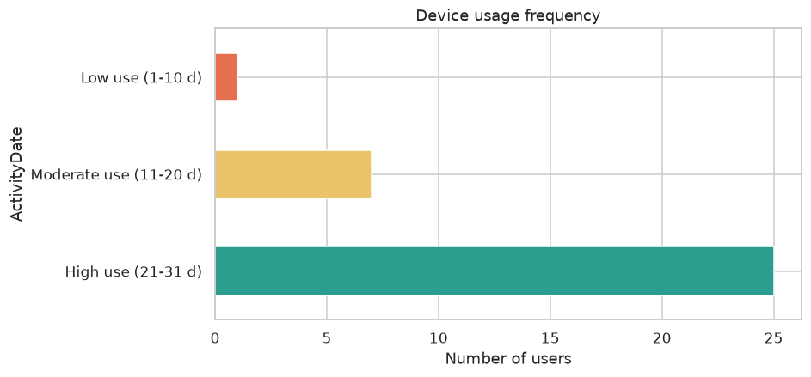
Device usage frequency: most users wear it almost every day.

Result
Visualizations supporting the key findings, ready for presentation.

6. Act — Recommendations

Objective
Translate the insights into concrete marketing actions.

Chosen product
The Bellabeat app (with a focus on the Leaf/Time tracker), the central touchpoint that connects all devices.

Top 3 recommendations
- Anti-sedentary campaign with smart reminders in peak windows (12-2pm and 5-7pm) and realistic goals (e.g. +1,000 steps/day).
- Promote sleep tracking as a flagship feature, communicating "move by day, sleep better at night" — an ideal lever for premium membership.
- Data-driven marketing at peak-usage times and gamification of the steps->calories feedback (badges, streaks) to boost retention and upsell.

Next steps and limitations
- Validate the insights on a larger, more recent dataset with female demographics.
- A/B test the notifications at peak times before rollout.
- Integrate hydration (Spring) and menstrual cycle data for the Bellabeat target.

Tools and deliverables
- Language: Python 3.12 (pandas, matplotlib, seaborn) in a Jupyter Notebook.
- Files produced: Bellabeat_Case_Study.ipynb (commented analysis), Bellabeat_Case_Study.html (browsable version), this .docx document and the figures in /figures.
- Data: FitBit Fitness Tracker Data (Kaggle, CC0).

